**Find Your Meds**

**Organization**: Nexera

**Prepared by**: I220950 Azfar Bilal

I221033 Maria Zahid

I220920 Aashir Hameed

**Table of Contents**

1. Introduction  
   1.1 Purpose  
   1.2 Product Scope  
   1.3 Title  
   1.4 Objectives  
   1.5 Problem Statement
2. Overall Description  
   2.1 Product Perspective  
   2.2 Product Functions  
   2.3 List of Use Cases  
   2.4 Extended Use Cases  
   2.5 Use Case Diagram
3. Other Nonfunctional Requirements  
   3.1 Performance Requirements  
   3.2 Safety Requirements  
   3.3 Security Requirements  
   3.4 Software Quality Attributes  
   3.5 Business Rules  
   3.6 Operating Environment  
   3.7 User Interfaces
4. Domain Model
5. System Sequence Diagram
6. Sequence Diagram
7. Class Diagram
8. Package Diagram
9. Deployment Diagram

**1. Introduction**

**1.1 Purpose**

The purpose of the *Find Your Meds* system is to provide an integrated platform for managing pharmacies, medicines, and customer interactions. The system caters to drugstore owners, customers, and administrators by streamlining operations like medicine management, order placement, and customer feedback.

**1.2 Product Scope**

*Find Your Meds* bridges the gap between pharmacies and customers by offering features like:

* Searchable inventory for medicines.
* Customer orders and their approval.
* Pharmacy feedback management.
* Secure administrative controls for pharmacy and owner approvals.

**1.3 Title**

**Find Your Meds**

**1.4 Objectives**

* Provide a user-friendly interface for pharmacy owners, customers, and administrators.
* Ensure real-time data management for medicine inventories and orders.
* Simplify approval workflows for pharmacy owners.
* Facilitate customer feedback collection.
* Provide a user-friendly platform for locating pharmacies with the required medicines based on real-time availability.
* Enable pharmacy owners to maintain and update their stock levels, ensuring accurate information for customers.
* Minimize the time spent by individuals searching for medications, especially during emergencies.
* Offer transparency in medicine pricing and availability across multiple stores.

**1.5 Problem Statement**

The search for specific medications during emergencies or odd hours can be stressful, time-consuming, and sometimes futile. Many people face situations where they have to visit multiple pharmacies to find the required medicine, often in a critical state. The lack of centralized information on medicine availability, price, and location adds to the burden. "Find Your Meds" aims to address this issue by creating a platform that allows users to instantly find pharmacies with the desired medicines, based on real-time data provided by the registered drugstores. By facilitating this, the app enhances the efficiency of medical access and reduces the physical and emotional toll of searching for medicines at inconvenient times. It is feasible because of the widespread use of smartphones and location-based services, combined with pharmacies' willingness to manage and share inventory digitally. The app benefits both consumers and pharmacies, streamlining the supply of medicines and boosting business for the latter.

**2. Overall Description**

**2.1 Product Perspective**

*Find Your Meds* is a standalone system designed for seamless integration with pharmacies and their customers. The system includes:

* Admin controls for overseeing pharmacy registrations.
* A searchable interface for customers to locate medicines.
* Customers can give feedback for the pharmacies
* Automated workflows for managing orders and approvals.

**2.2 Product Functions**

* Pharmacy Inventory Management
* Order Management and Tracking
* Feedback and Reviews Handling
* Owner Registration Approval

**2.3 List of Use Cases**

* Search for Medicines
* Place Orders
* Manage medicine
* Manage pharmacy
* Dispatch Order
* Manage Inventory
* Approve Drugstore Owner
* View Feedback

**2.4 Use Case Diagram**

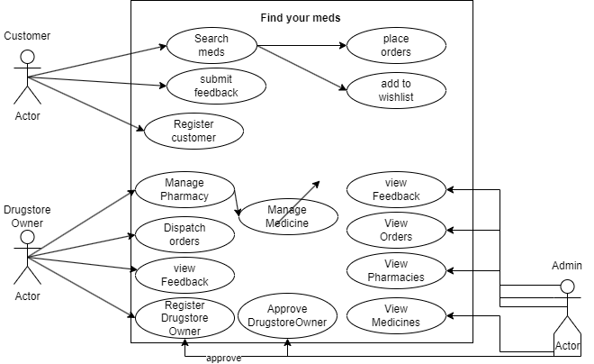

**3. Other Nonfunctional Requirements**

**3.1 Performance Requirements**

* The system must handle up to 10,000 active users concurrently.
* Inventory searches must return results within 3 seconds.

**3.2 Safety Requirements**

* Prevent unauthorized pharmacy data edits.
* Implement backups to avoid data loss.

**3.3 Security Requirements**

* Admin login must be authenticated.
* Customer orders must only be accessible to authorized pharmacy owners.

**3.4 Software Quality Attributes**

* **Usability**: Simplified UI for users across varying technical expertise.
* **Reliability**: Ensure uptime of 99.9% through redundancy mechanisms.

**3.5 Business Rules**

* Customers can only order medicines listed in the inventory.
* Admin must approve pharmacy registrations before operations commence.

**3.6 Operating Environment**

* Built with JavaFX for front-end and MySQL for the database.

**3.7 User Interfaces**

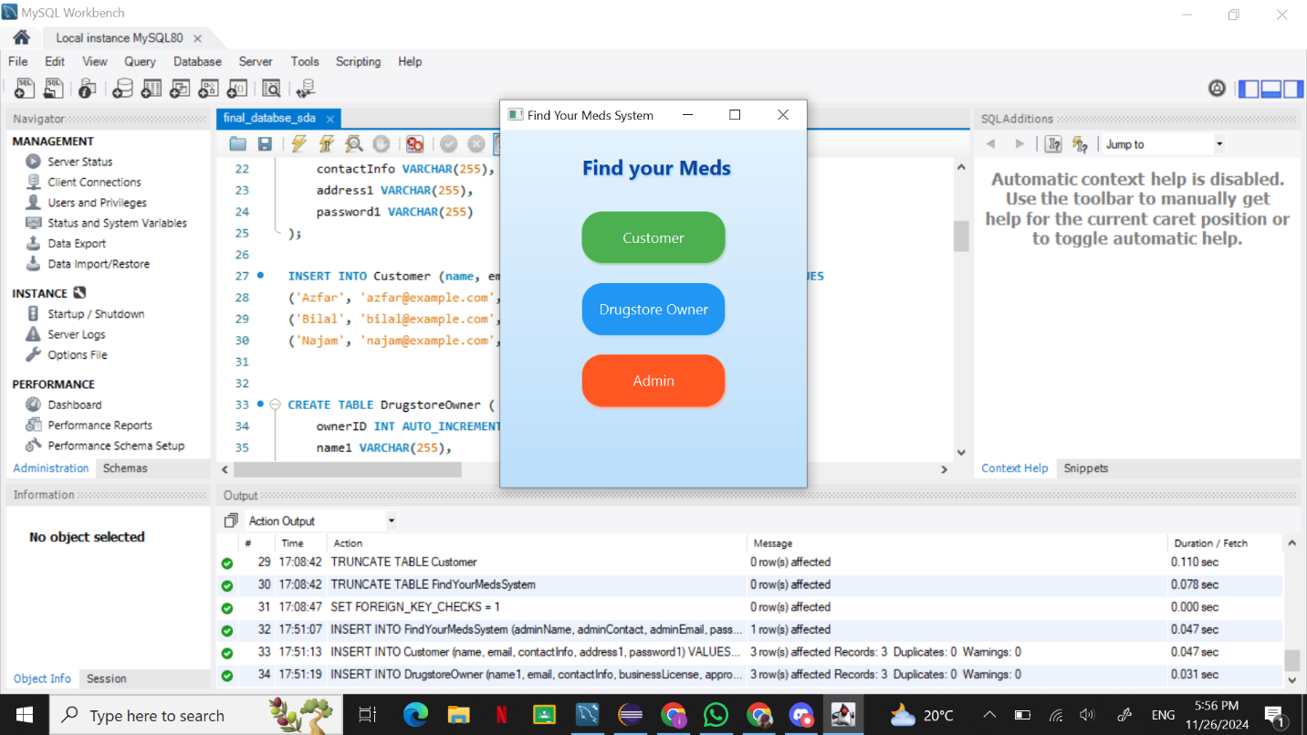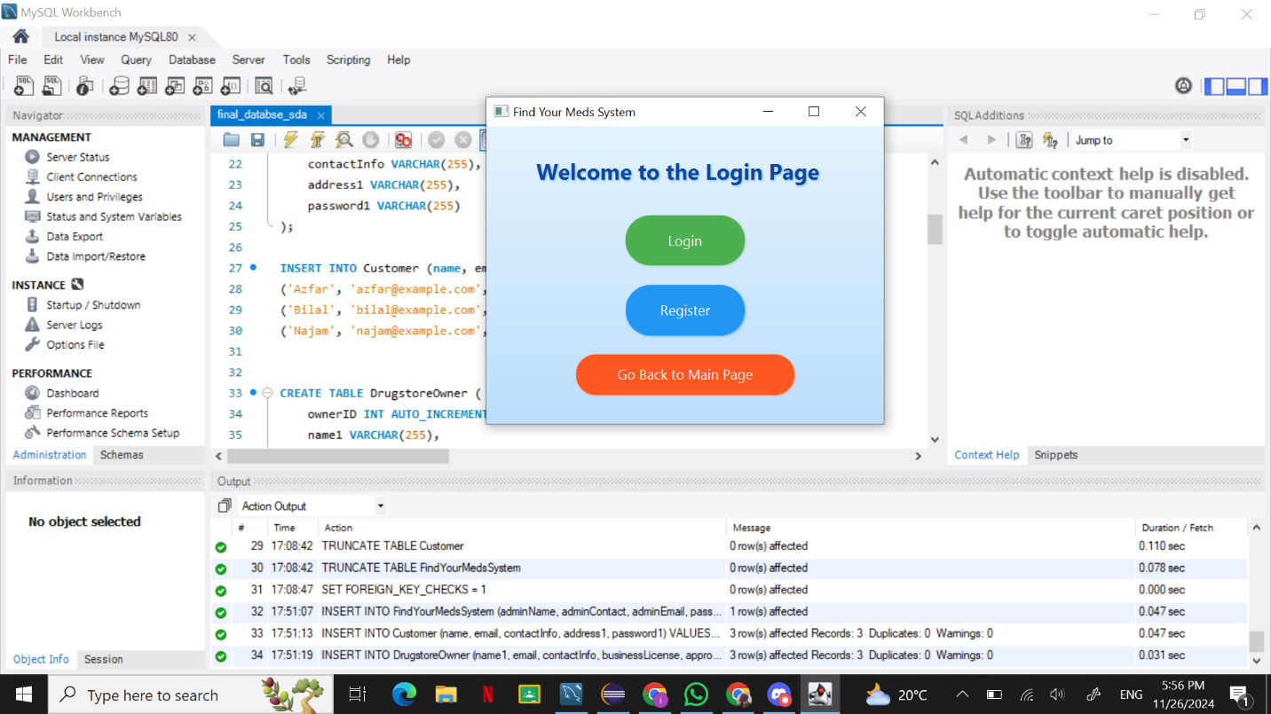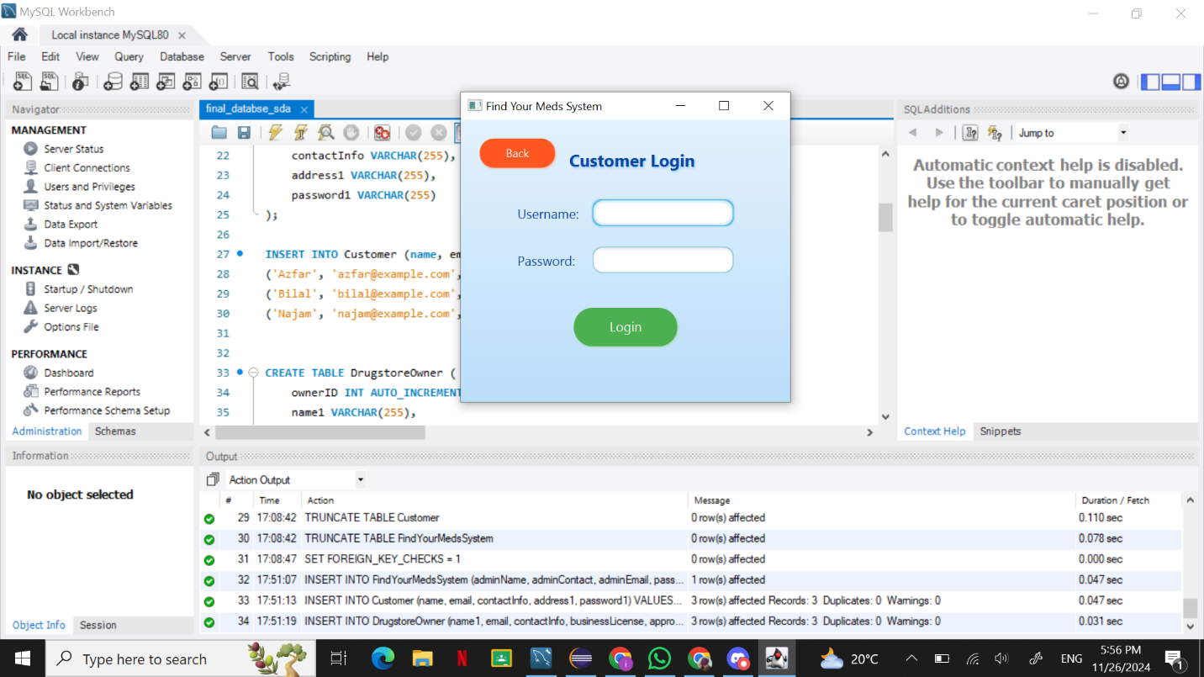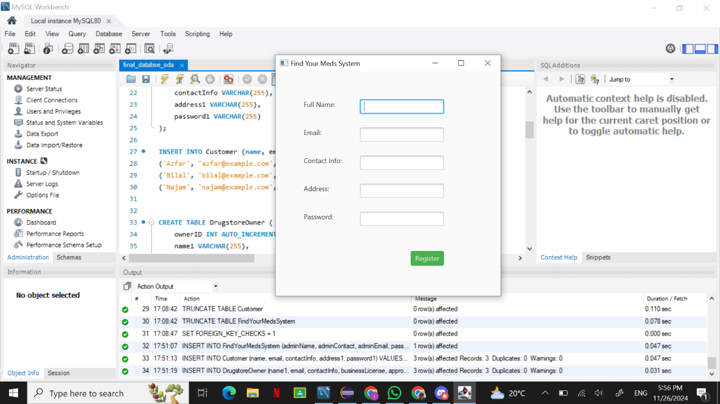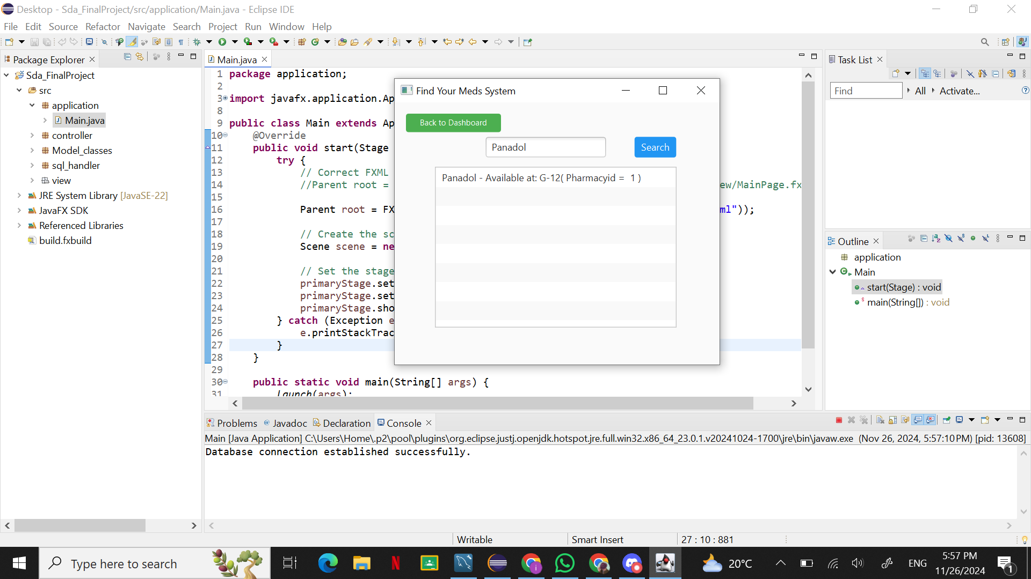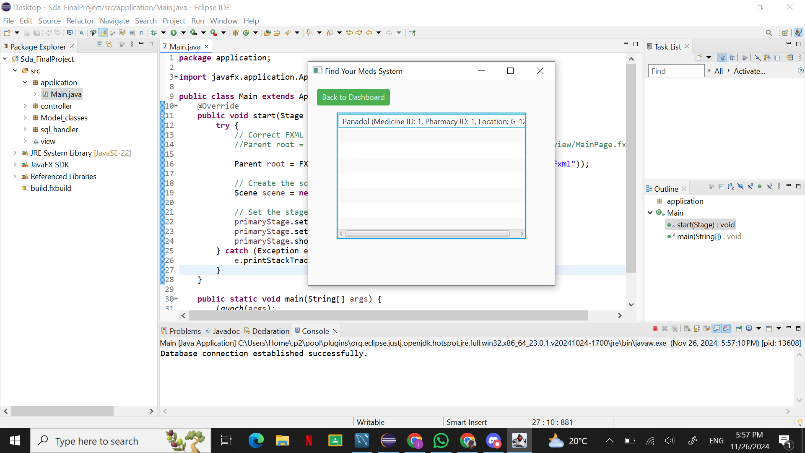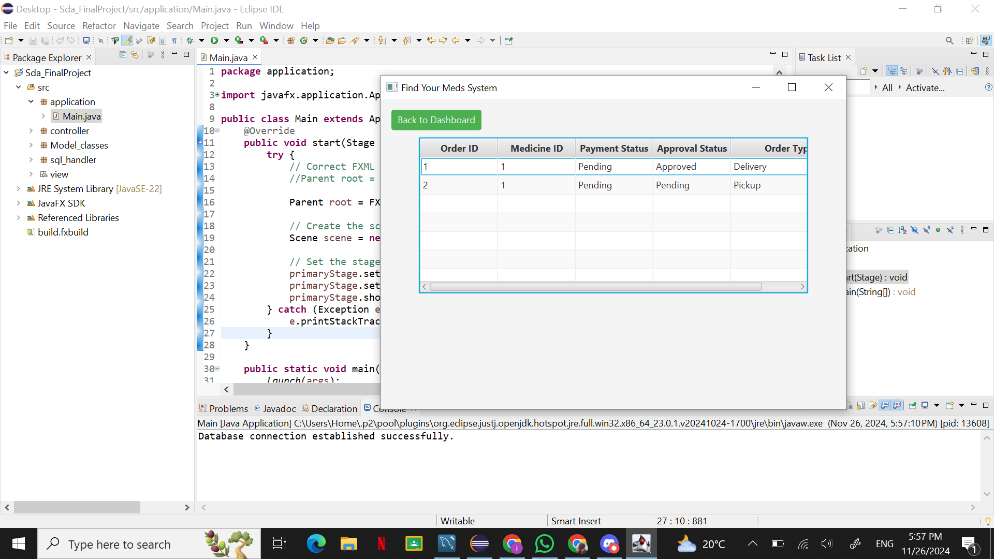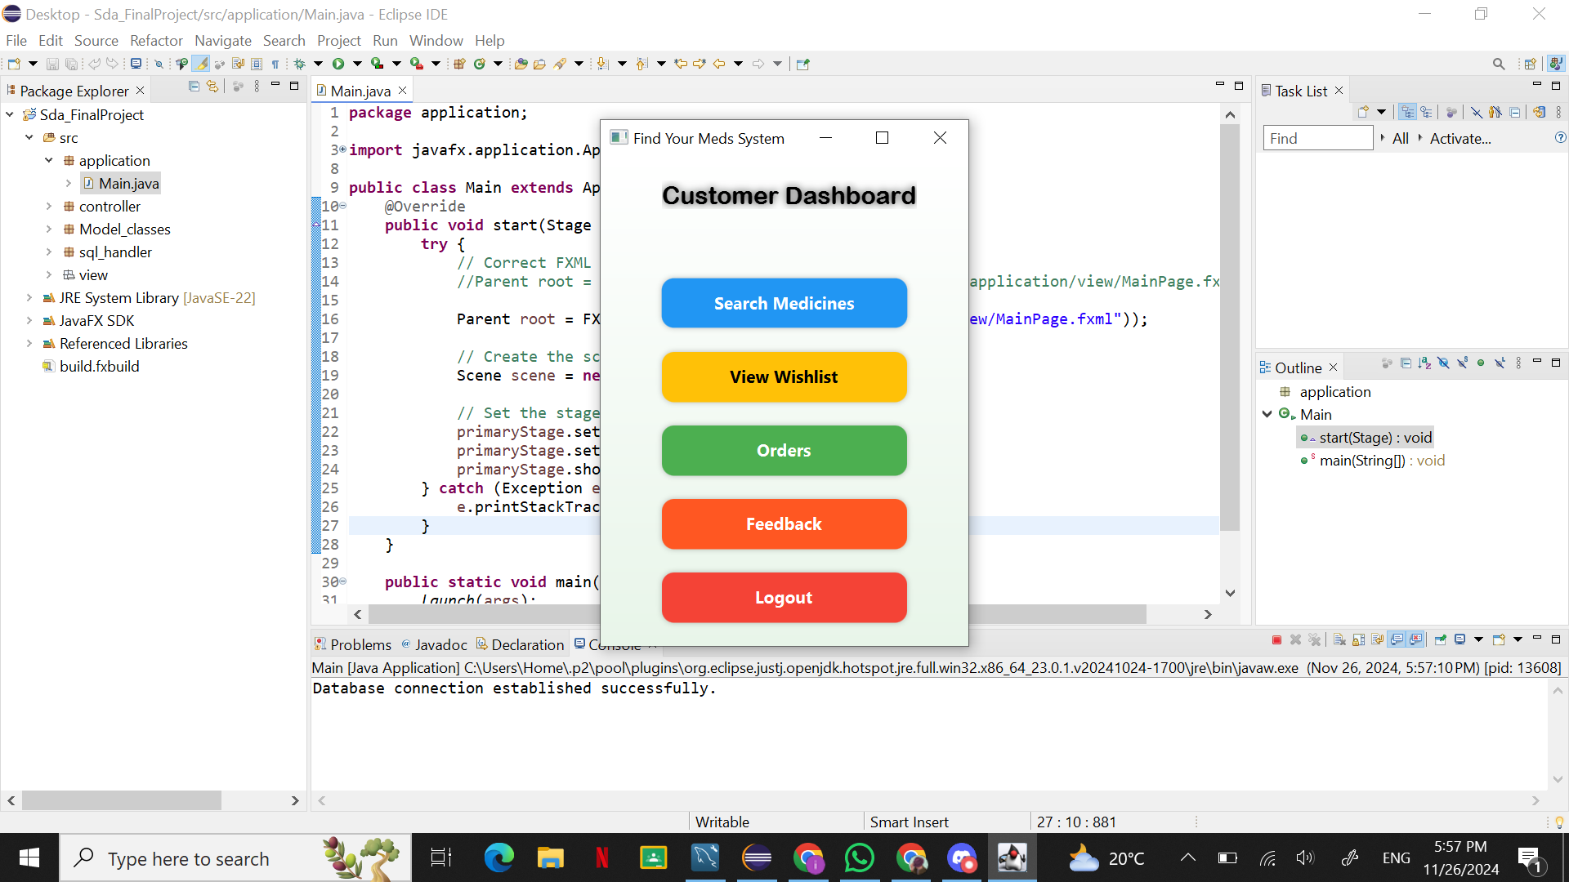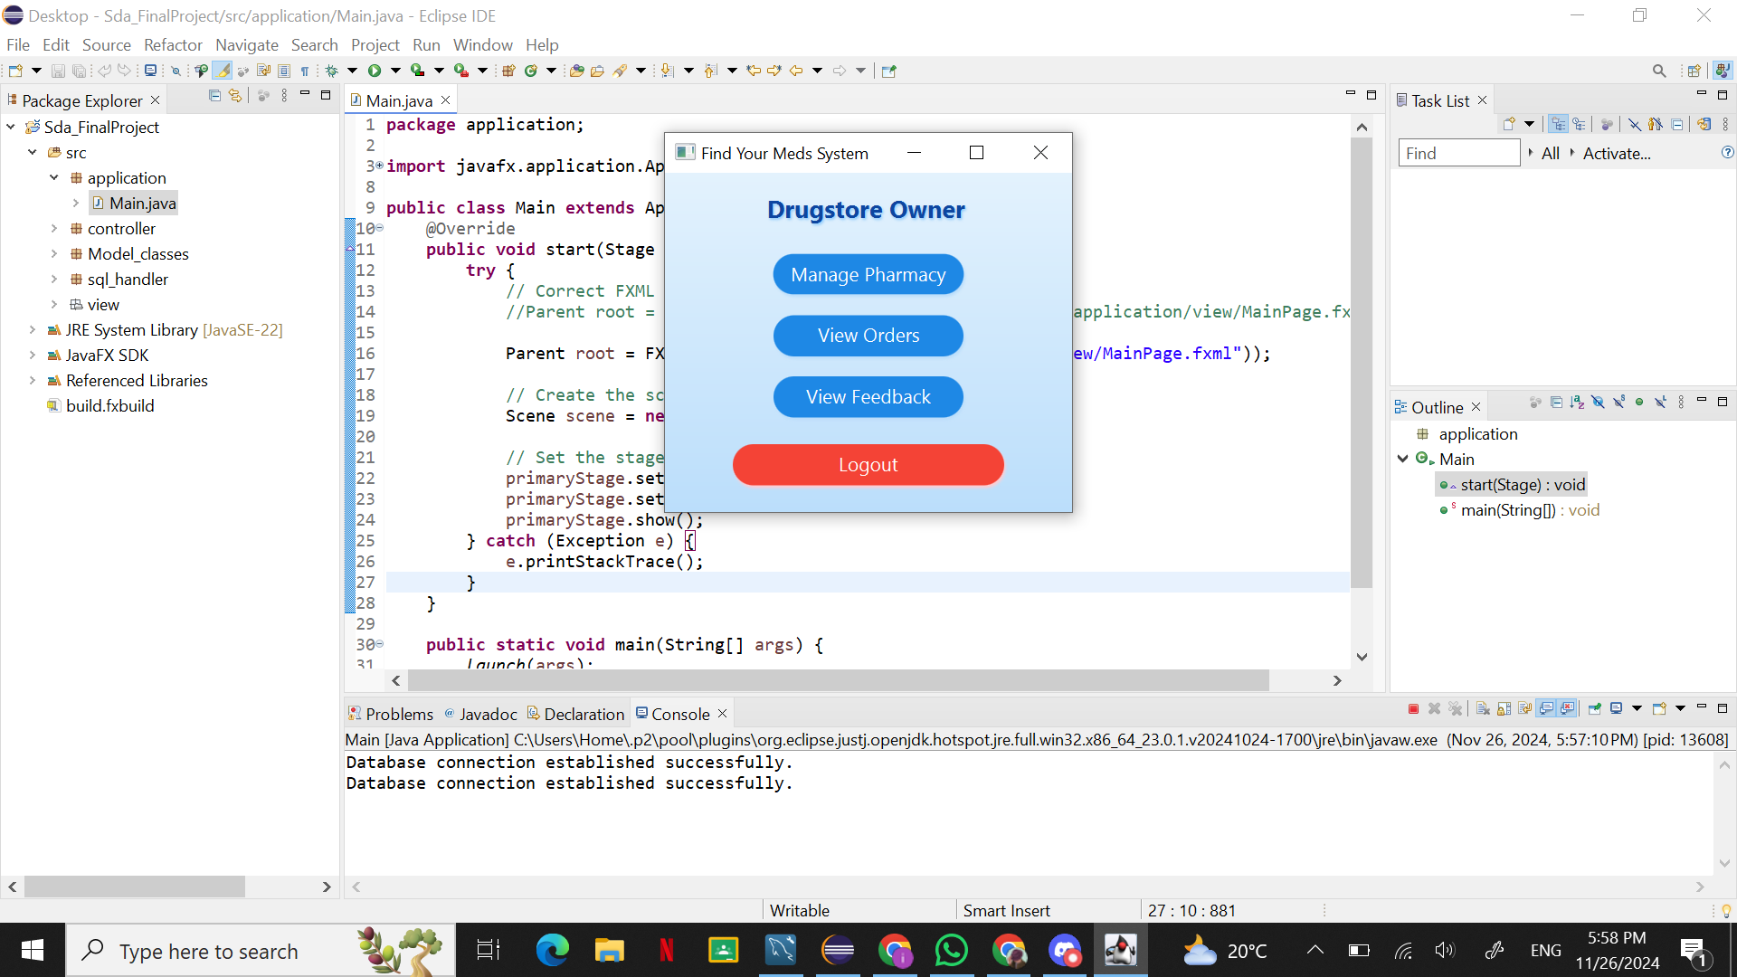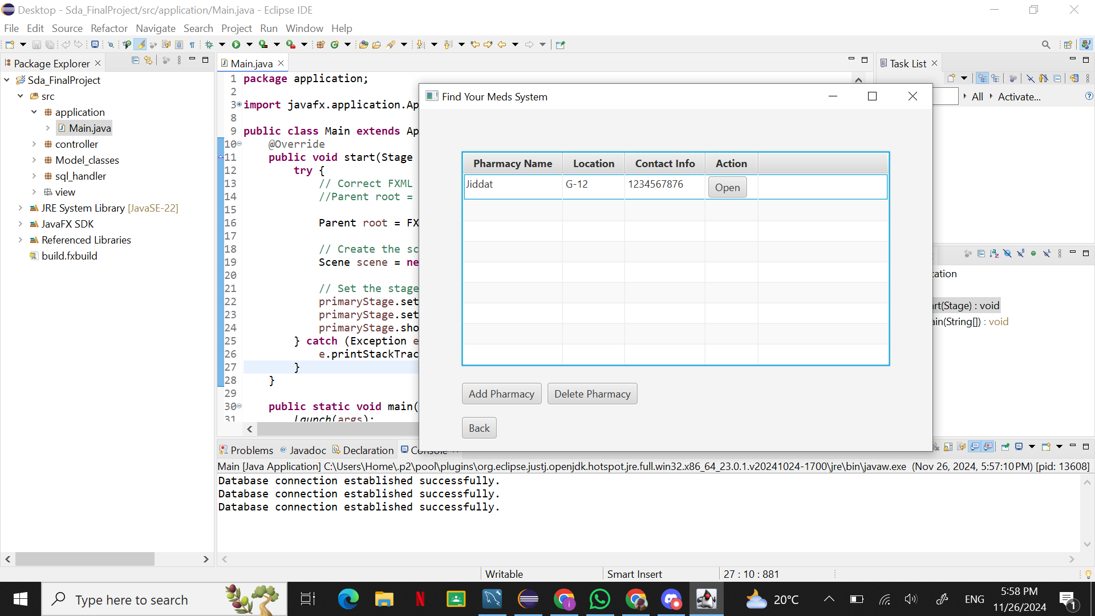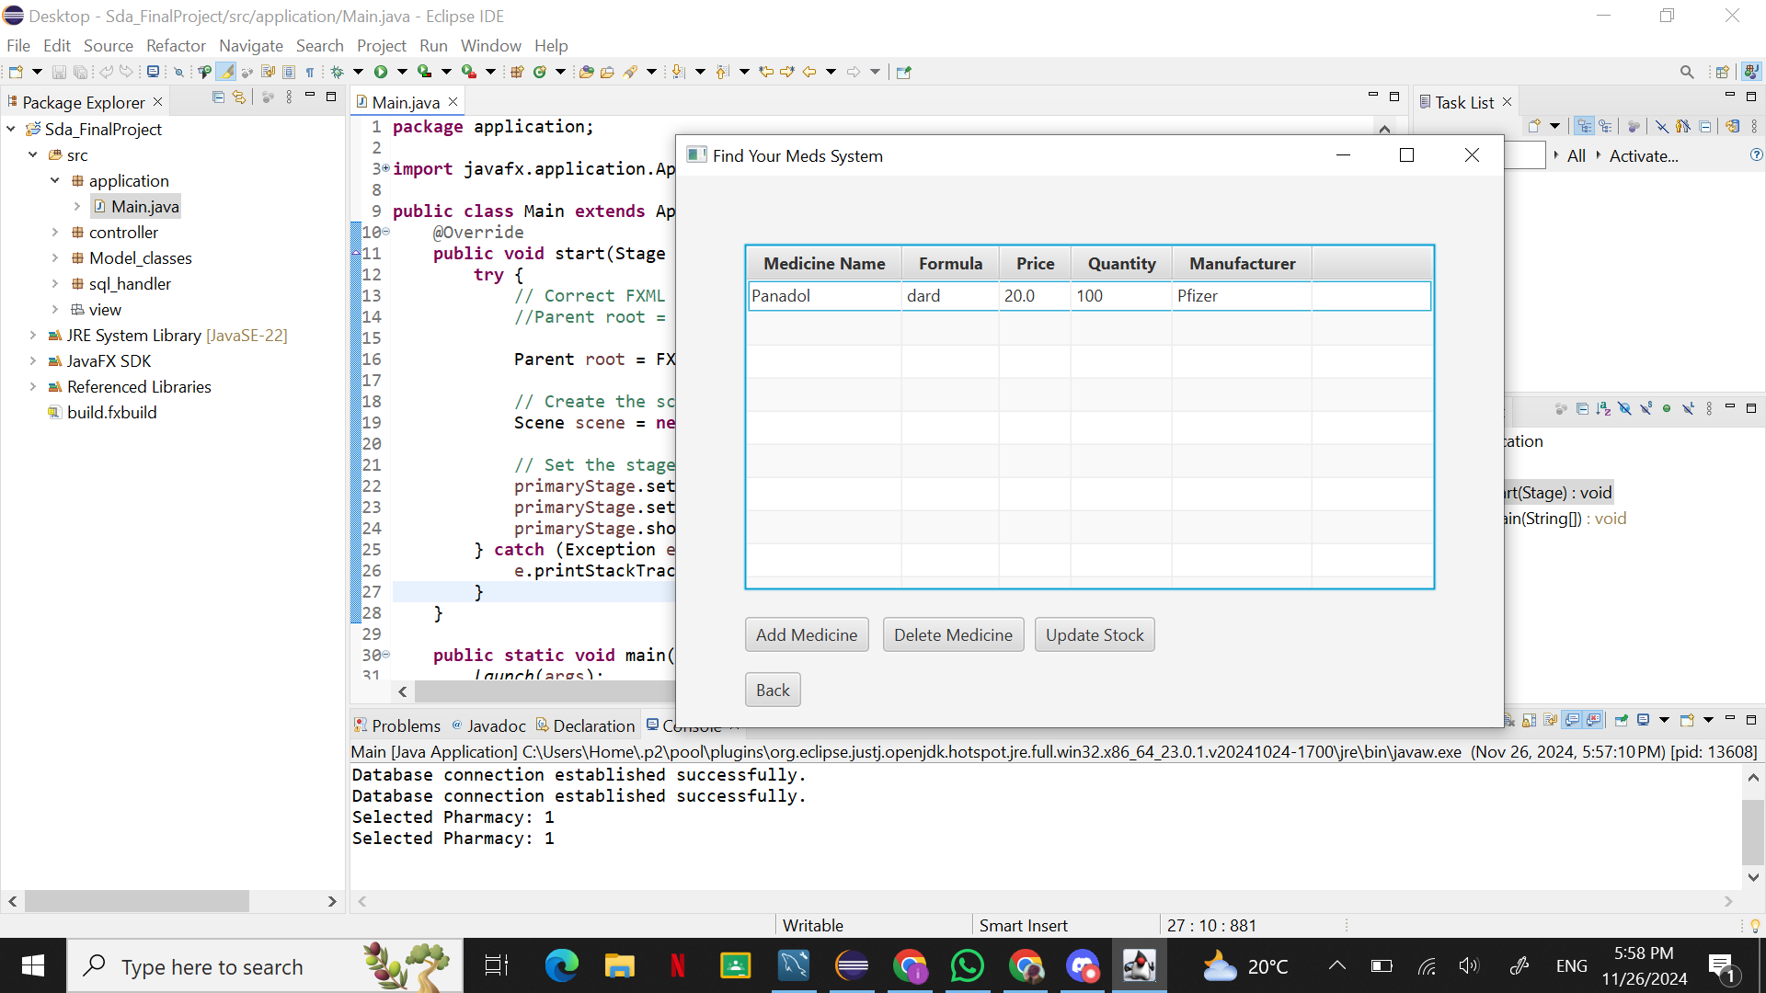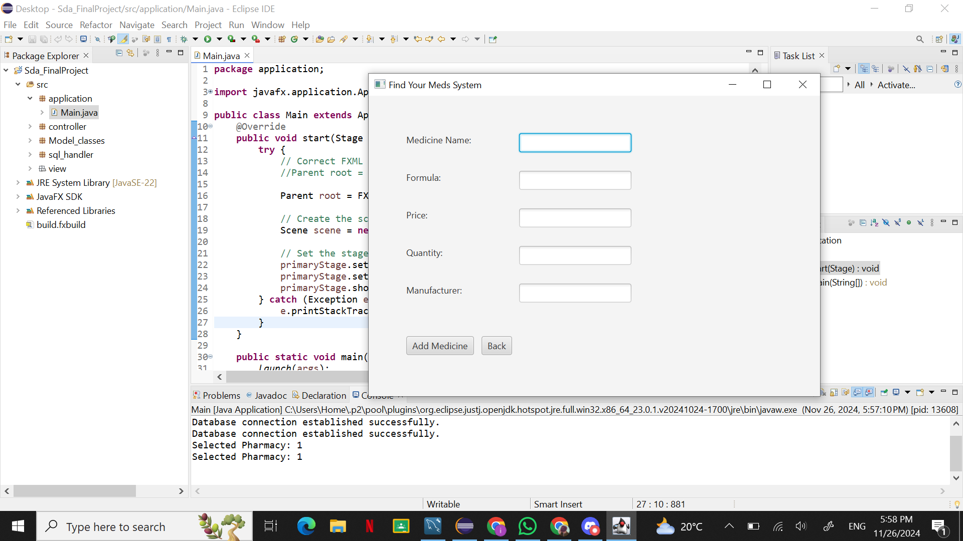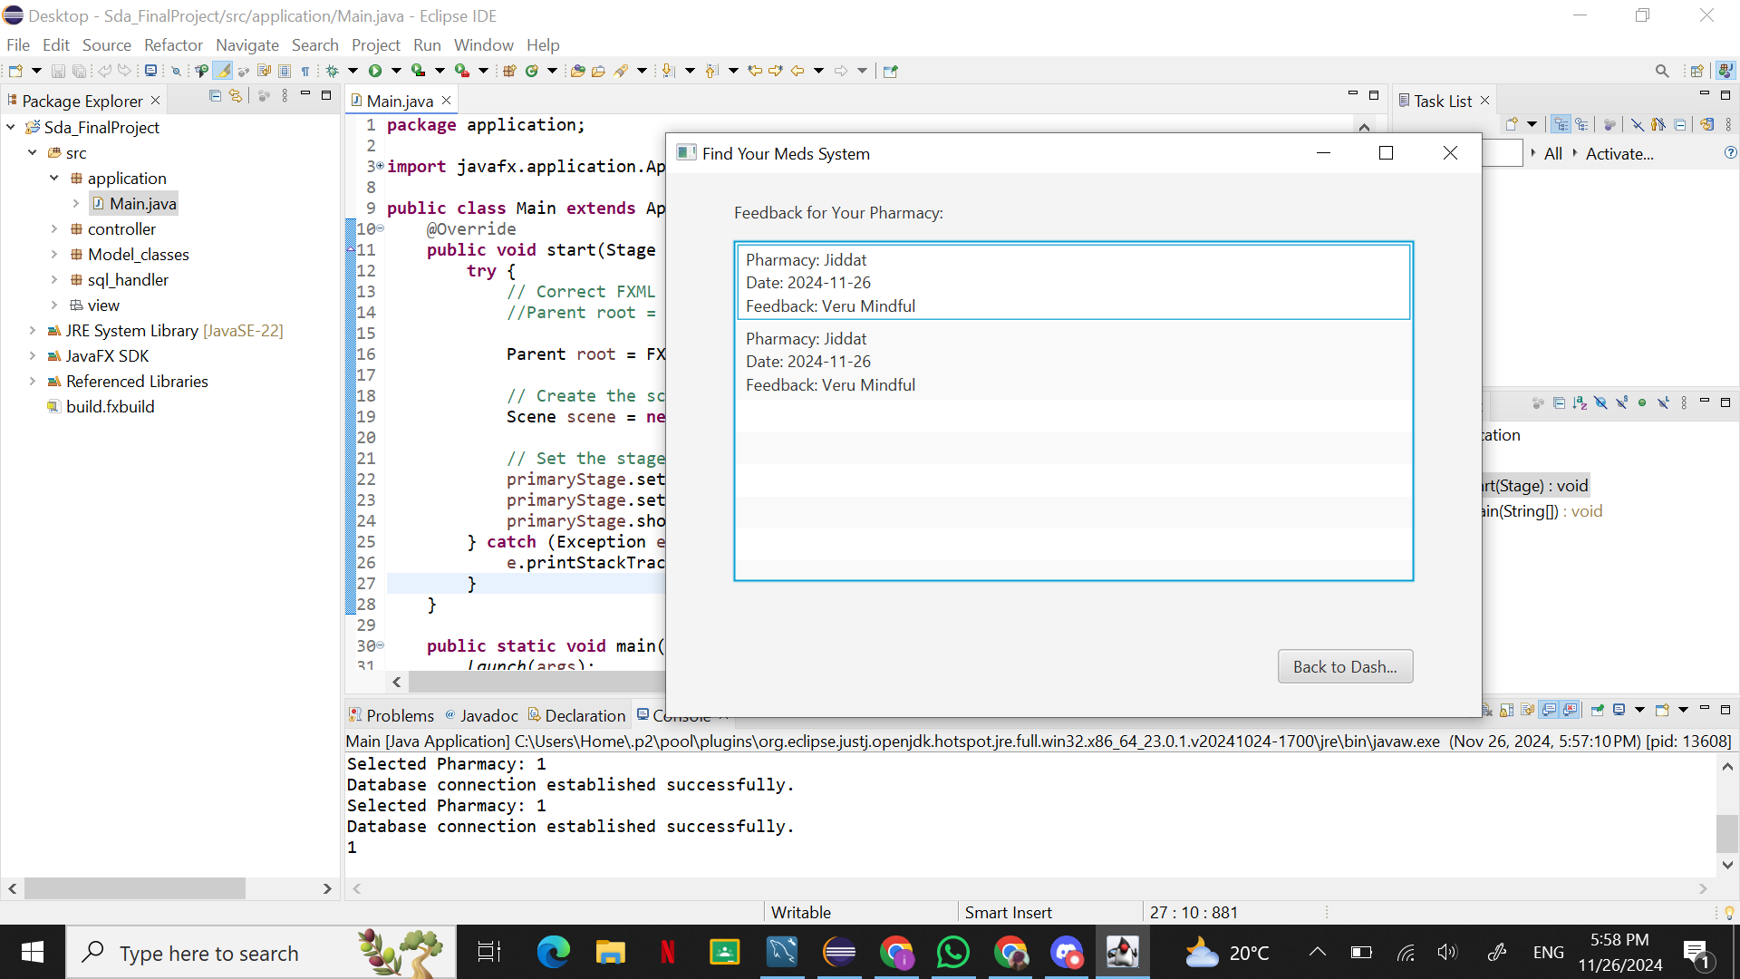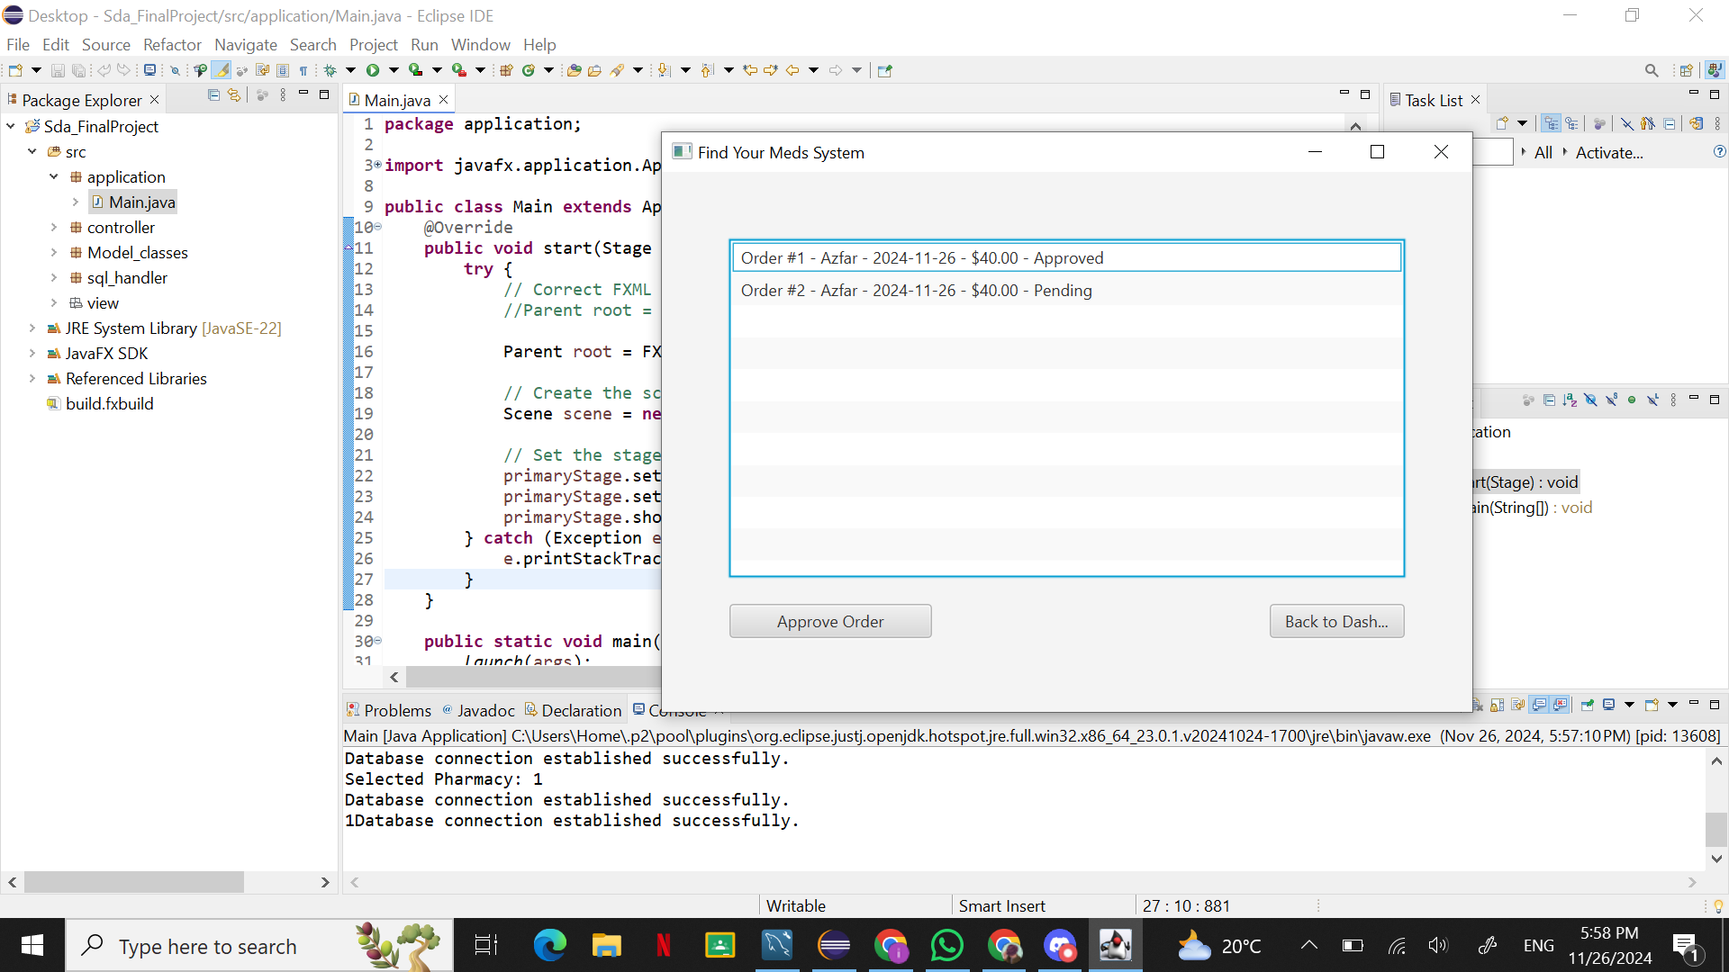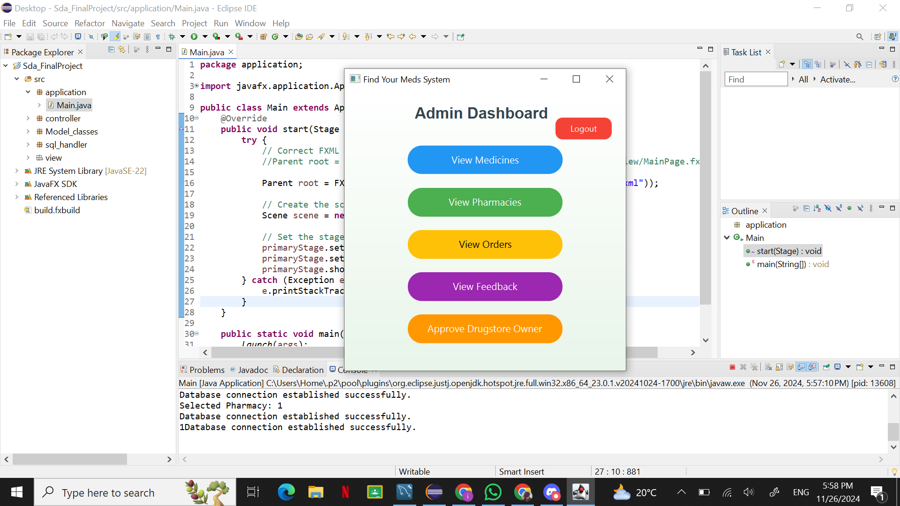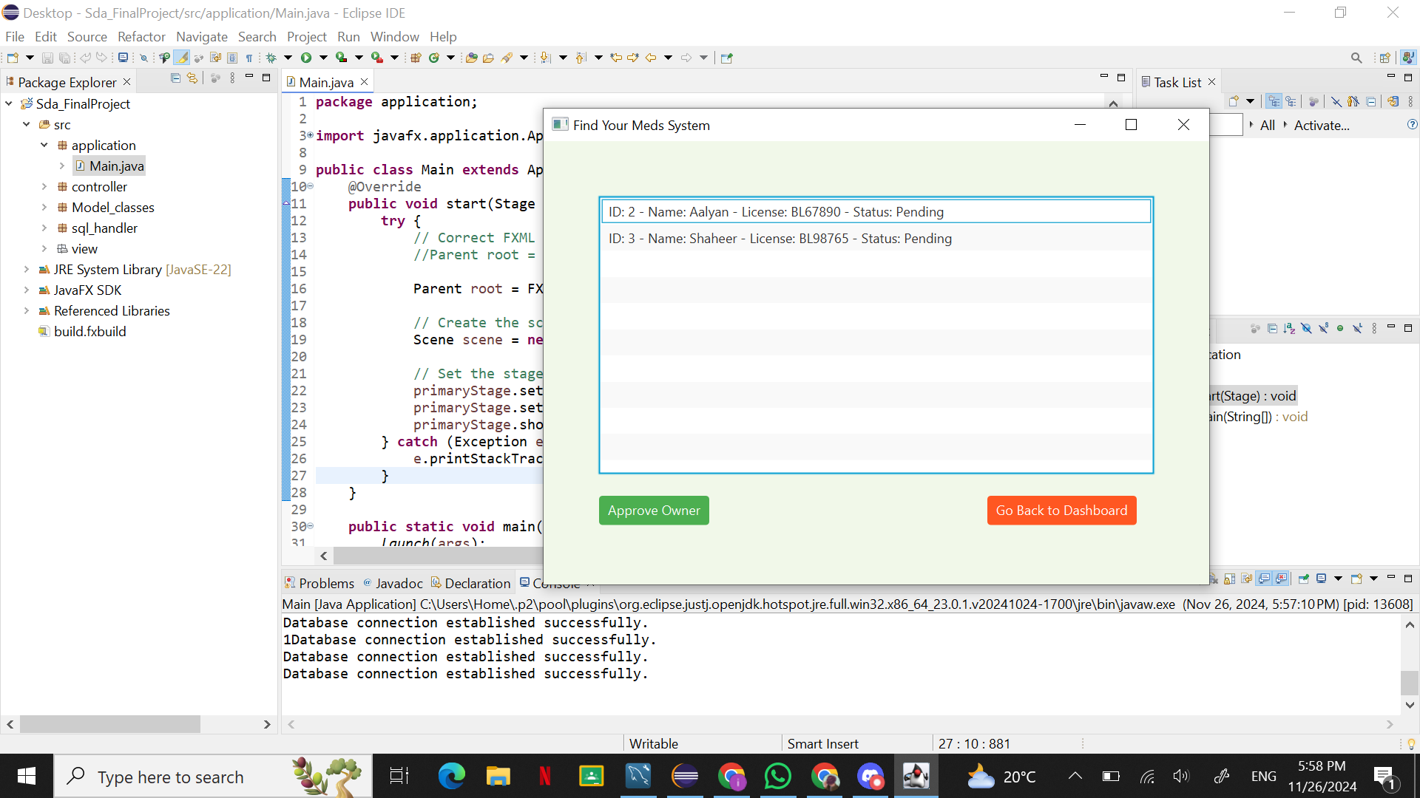

**4. Domain Model**

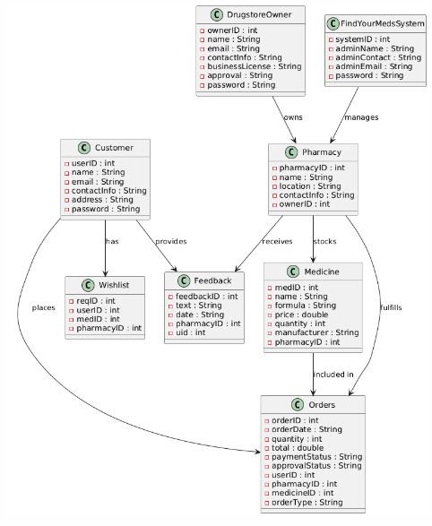

**5. System Sequence Diagram**

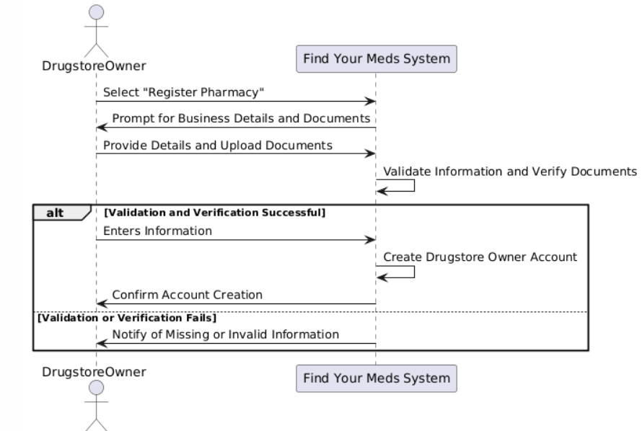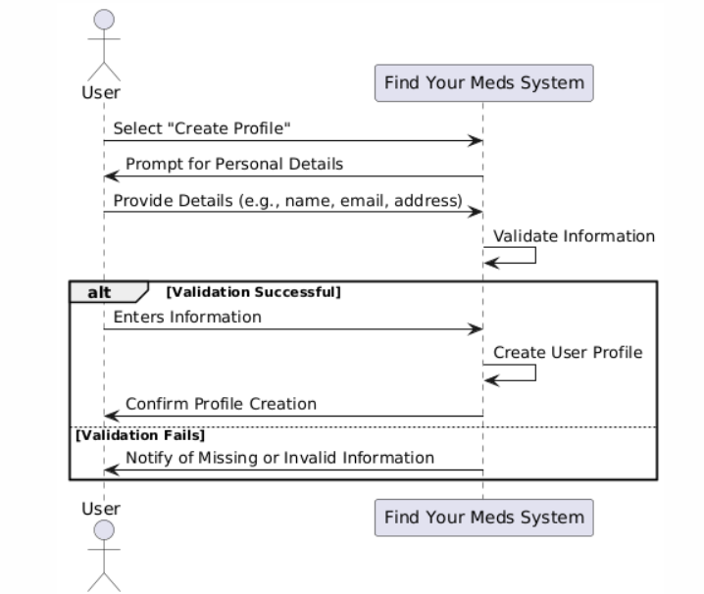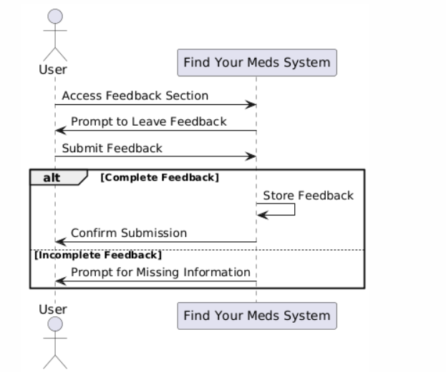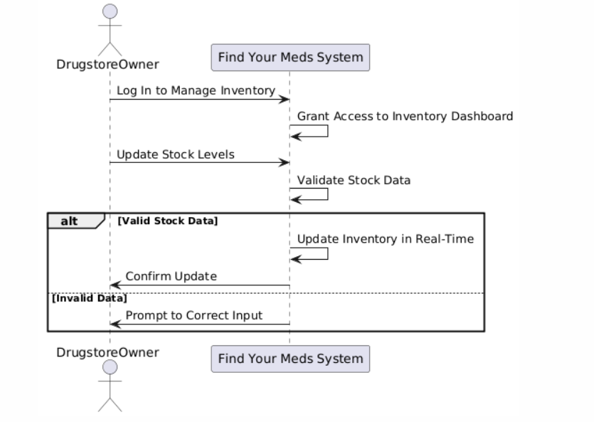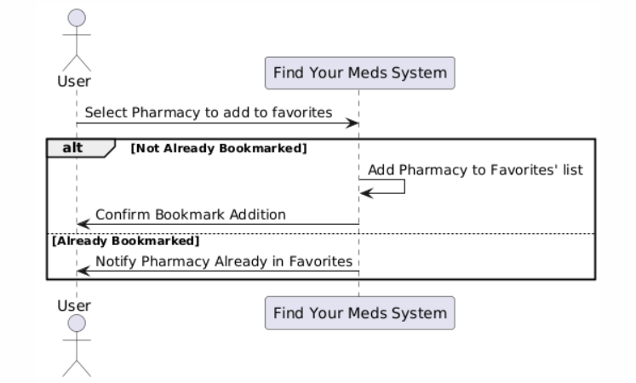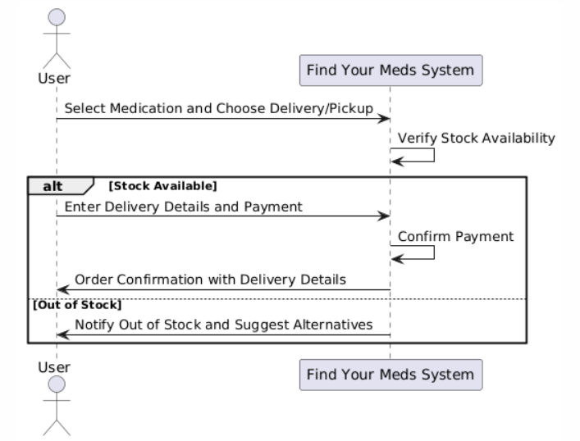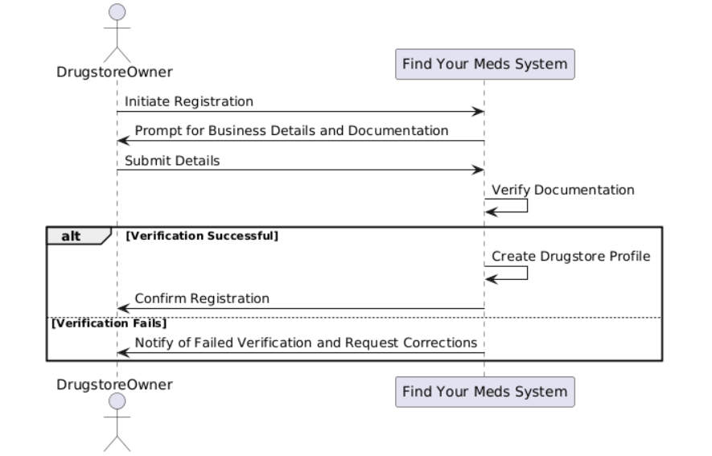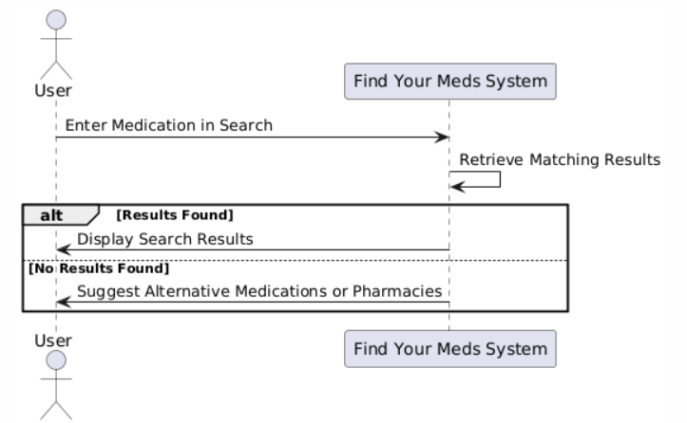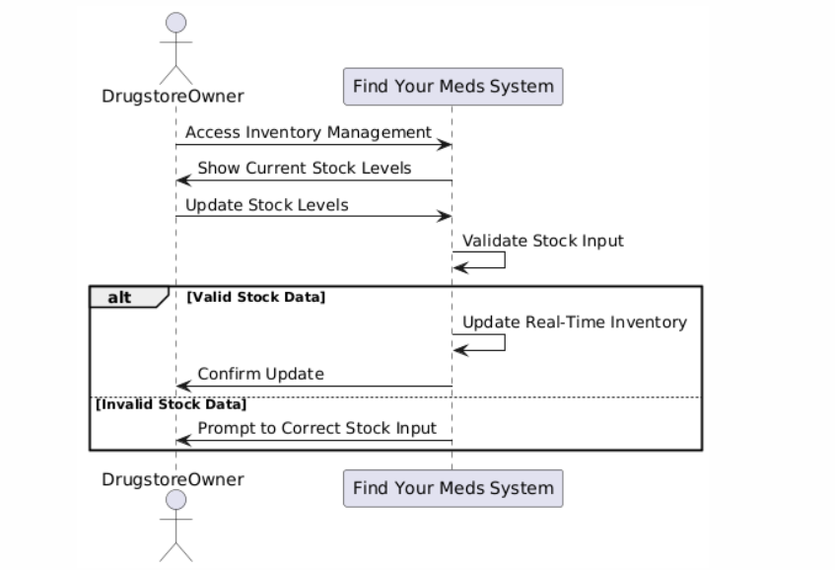

**6. Sequence Diagram**

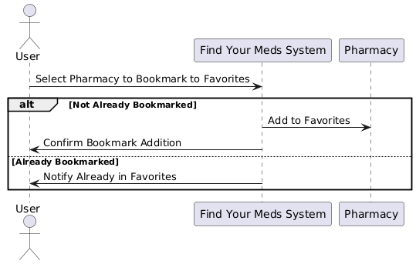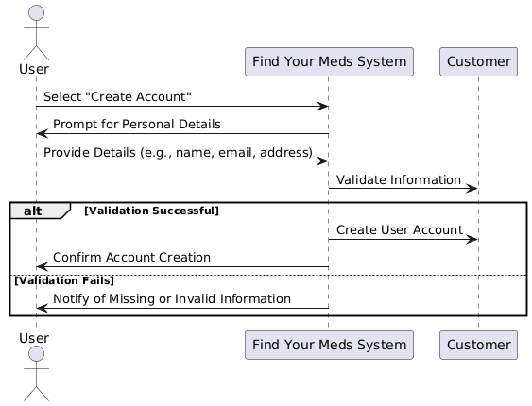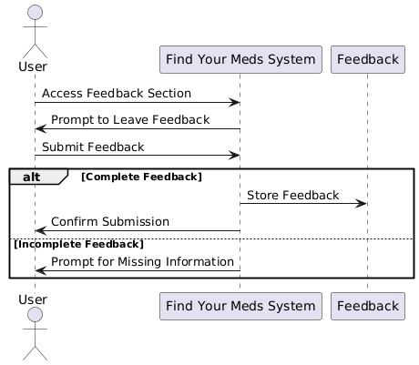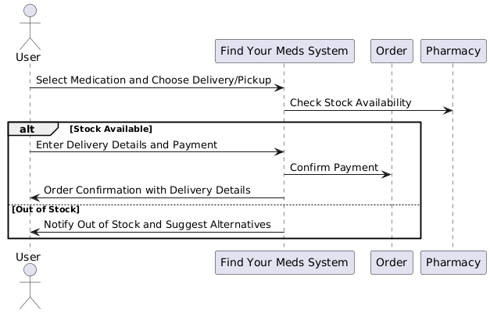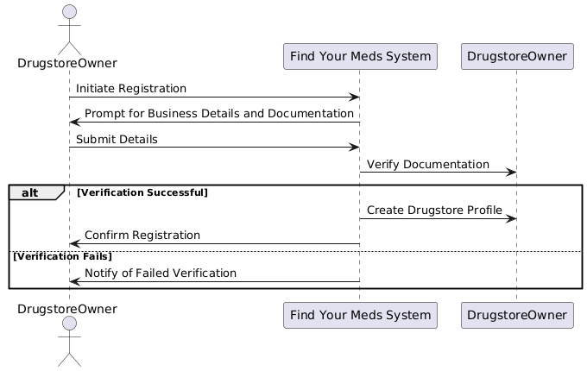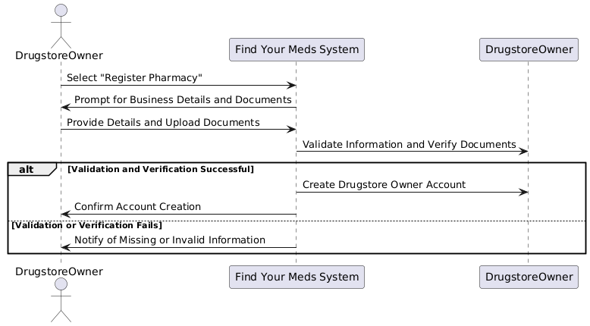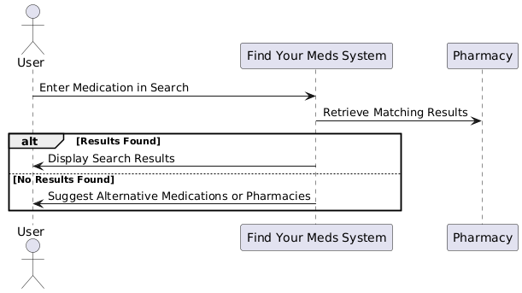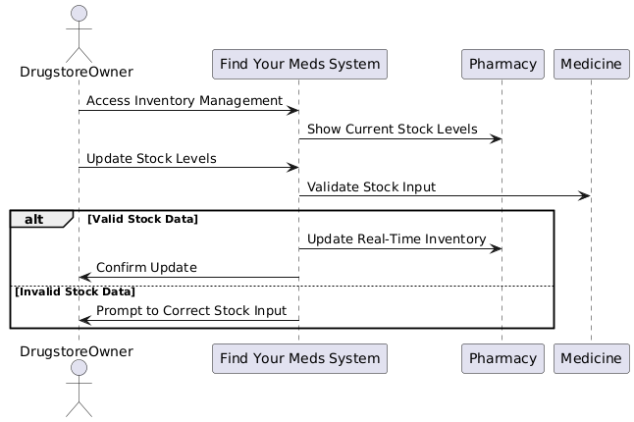

**7. Class Diagram**

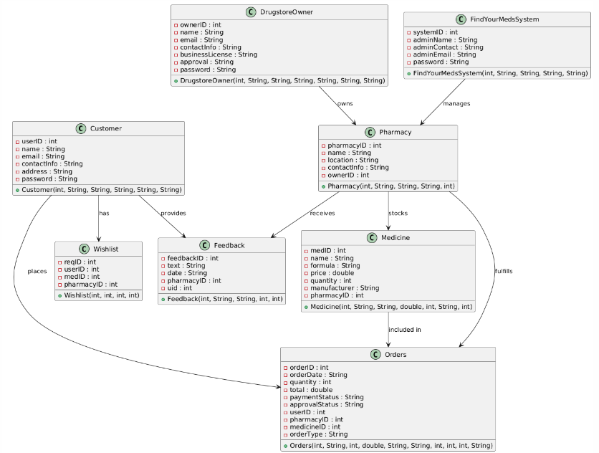

**8. Package Diagram**

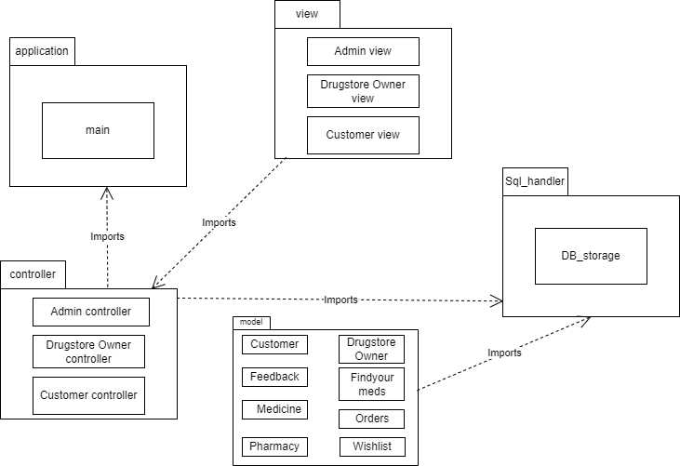

**9. Deployment Diagram**

